# Example Business letters

Example A

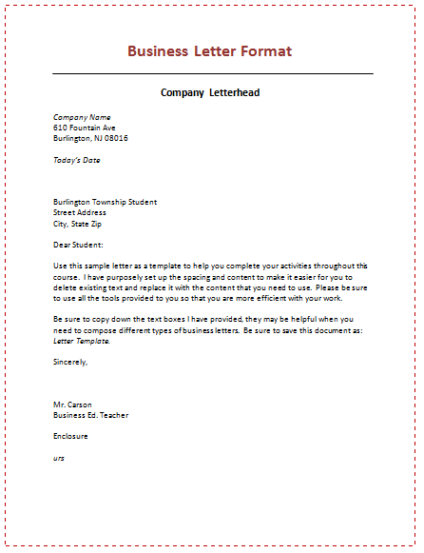

Source: <http://www.doctemplates.net/6-samples-of-business-letter-format/>

Example Salutations

Example B

This shows each aspect of the business letter required

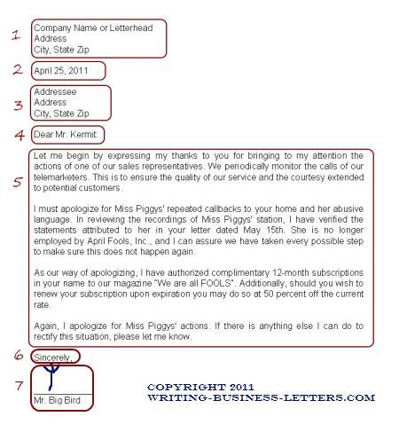

Source: <http://www.sampleletterpro.com/business-letter-format.html>